EXAMPLE ABSTRACTS

Understanding the effects of tropical rainforest fragmentation on tree communities and carbon storage: a functional traits approach
Presented by
Anand Osuri
National Centre For Biological Sciences
Authors
Anand Osuri And Mahesh Sankaran

Introduction: What conservation problem or question does your study address?
The conservation of biodiversity and ecosystem services in the tropics is increasingly dependent on forests that are fragmented and disturbed. However, the mechanisms by which fragmentation alters the structure and functioning of ecosystems remain poorly understood. In this study, we use an analysis to plant functional traits to gain insights into the processes by which rainforest fragmentation alters tree community composition and carbon storage.

Methods: What were the main research methods you used?
The study employed an analysis of plant functional traits to examine linkages between forest fragmentation, tree community turnover and carbon storage potential. The objectives were (1) to identify the traits which best predict tree community turnover from contiguous to fragmented forests, and (2) identify relationships between the traits which structure tree communities in fragments and those which determine carbon storage potential. The study was conducted in nine contiguous and nine fragmented rainforests in the Western Ghats Mountains. Tree communities were sampled using replicated inventory plots. A set of plant functional traits which relate to key life history processes were sampled following standard protocols. Inter-trait relationships were described using pairwise correlations and trait-fragmentation interactions were identified using mixed-effects models.

Results: What are your most important results?
Functional traits related to seed dispersal processes were identified as the most important predictors of community turnover from contiguous to fragmented forests, with fragments dominated by small-seeded species. At the community level, seed size was positively associated with species’ adult heights, suggesting the structuring of tree communities by altered seed dispersal processes may affect carbon storage by promoting shorter-statured forests over time.

Discussion: What are your important discussion points and what is the relevance of your results to conservation (if any)?
While the role of local edge effects in structuring tree communities and reducing carbon storage is widely recognized, our results suggest that community turnover and carbon losses may be driven by altered seed dispersal processes acting at broader landscape scales. Alongside improved protection at the site level, efforts to secure connectivity at landscape-scales may be essential to sustain biodiversity and ecosystem services over time in fragmented landscapes.
Visual abstract
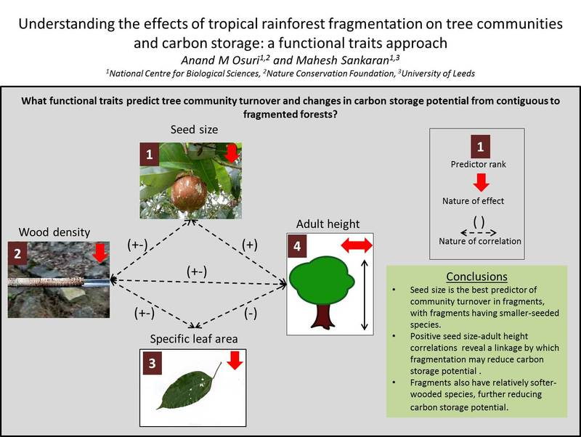

Forest governance in Central India: The case of the tendu leaf trade in Madhya Pradesh

Presenter: R. Venkat Ramanujam

Authors: SharachchandraLele, R. Venkat Ramanujam, and Jeetesh Rai

Introduction
The harvest of commercial non-timber forest produce (NTFP) is a source of livelihood for an estimated 100-275 million people in India. The trade in the tendu leaf, a key NTFP of Central India and an ingredient in the beedi or Indian cigarette, provides important insights into forest governance from an NTFP perspective. How is the tendu leaf trade carried out in the state of Madhya Pradesh and what are its implications for forests and forest-dwellers?

Methods
Six districts were covered, three each in the teak and sal-dominated regions between October 2010 and March 2012. Interviews were conducted with 35 functionaries associated with Minor Forest Produce Co-operative Societies. This was in addition to interviews with 22 forest department officials, 7 contractors, and 10 key informants. Household data on NTFP collection was gathered across 125 households. Participant observation was carried out during the tendu leaf harvest season in May-June 2011.

Results
Till the late 1980s, the tendu leaf trade was led by contractors who de facto dealt directly with leaf-plucking forest-dwellers. In 1989, tendu leaf procurement was handed over to specially-created 1,947 minor forest produce co-operative societies in the state of Madhya Pradesh. Since then the tendu leaf harvest is organised by a primary co-operative society, and sold by auction to a contractor for processing and onward sale to the beedi manufacturer. There are some advantages of the co-operative process especially in improving leaf-pluckers’ remuneration and developing a successful financial model. On the whole, however, there are glaring shortcomings, particularly in terms of empowering NTFP harvesters to think for themselves and taking their own decisions.

Discussion
The mandate of the societies is to allow NTFP harvesters to democratically engage in collective bargaining with potential traders in order to realise remunerative prices for all NTFP, and to create the conditions for sustainable harvesting. In practice, the co-operative societies (i) have been subverted by centralised decision-making led by forest officials rather than NTFP harvesters, (ii) have focussed largely on the tendu leaf trade despite their much wider mandate, (iii) are engaged in unsustainable harvesting in those pockets where they trade in medicinal plants, and (iv) are oblivious to the ecological implications of their trade on forest biodiversity. The continuation of the co-operative model needs to be debated both within the existence of its shortcomings as well as in the context of PESA, 1996 and the Forest Rights Act, 2006, legislation which provide for a paradigmatic shift in the relationship between forest-dwellers and their natural resources.

Visual Abstract
